CSE 350

Team #16

Class Model and Diagrams

Document

Ayush Thengne, Muhammad Seyal, Ivan Lamb, Stephanie Mcdonald, Ashleigh Gray, Carsten Kurtz

Version: 1.0 Date: 9/24/2022

State Transition Diagram:

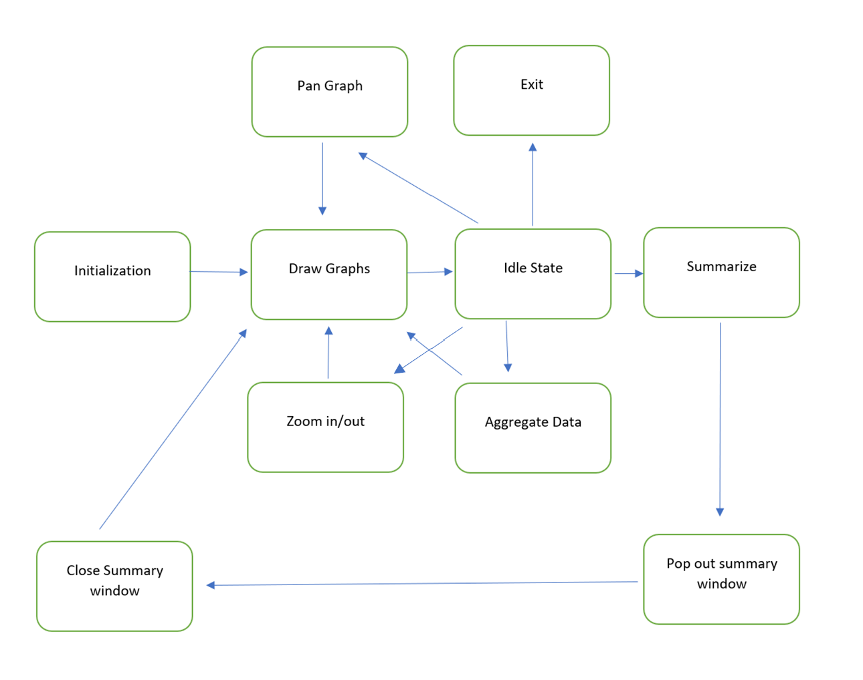

RDA:

|  |  |  |  |  |  |  |
| --- | --- | --- | --- | --- | --- | --- |
|  | Priority | 1 | 2 | 3 | 4 | 5 |
| Requirements |  |  |  |  |  |  |
| User Interface  For sensor Data |  | * |  |  |  |  |
| Sync across Time Series = |  |  | * |  |  |  |
| Switch between UTC and Local |  |  |  |  |  | * |
| Zoom in/ zoom out |  |  |  | * |  |  |
| Pan |  |  |  | * |  |  |
| Aggregate |  |  |  |  | * |  |
| Summarize |  |  |  |  | * |  |

Class Model:

